Truncated Cuboctahedron

Definition
# Source: AI Source: Provided by: [Data Path: Persons Table -> ID Column: 1, Name_En Column: Motasem Essam] -> From: [ChatGPT] on [7/25/2026]
A Truncated Cuboctahedron is a three-dimensional polyhedron formed by truncating the vertices of an original cuboctahedron using planes.
The truncation process creates new polygonal faces while modifying the original square and triangular faces.
It is classified as a uniform polyhedron and belongs to the family of Archimedean solids.

Geometric Structure
# Source: AI Source: Provided by: [Data Path: Persons Table -> ID Column: 1, Name_En Column: Motasem Essam] -> From: [ChatGPT] on [7/25/2026]
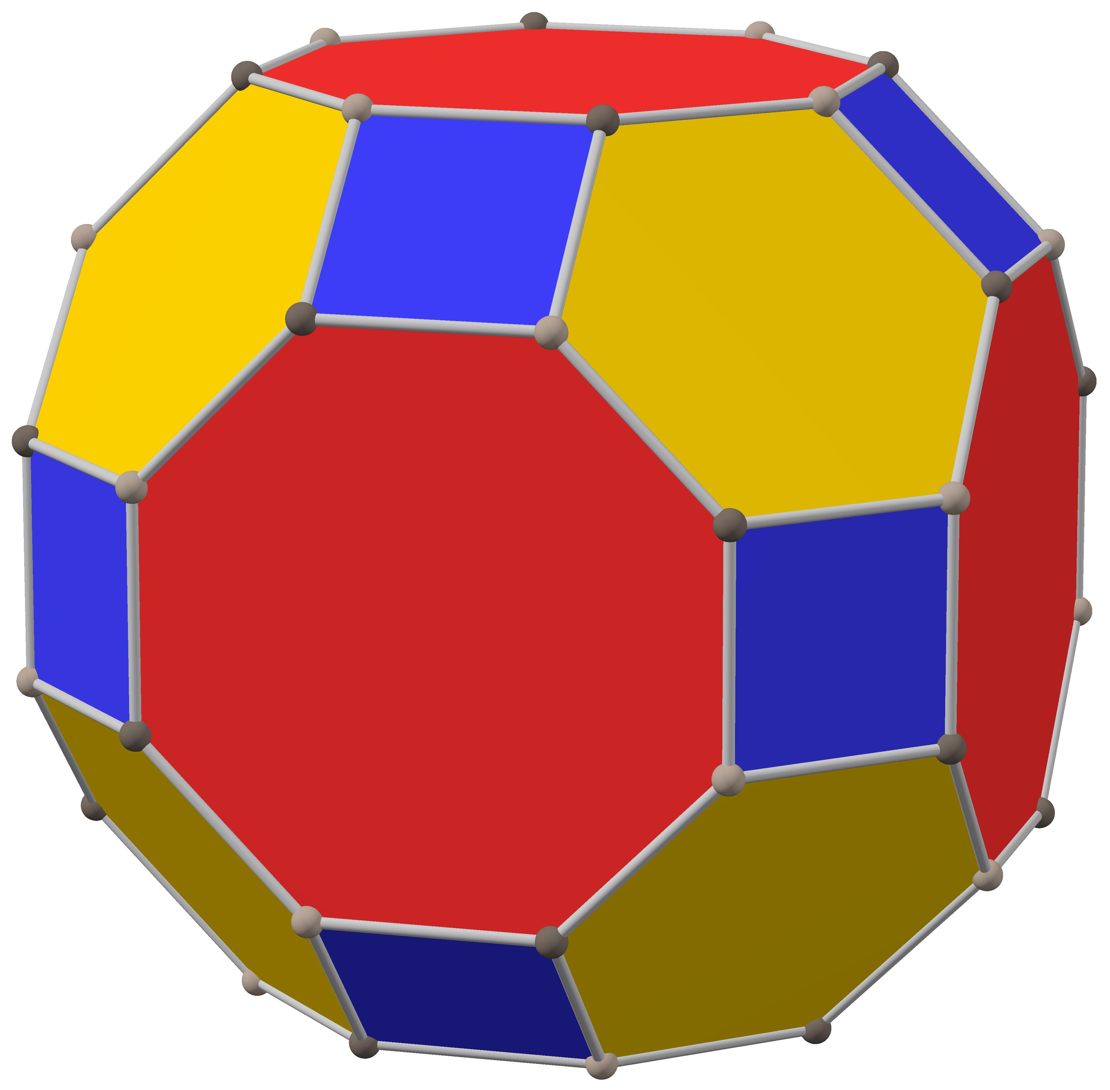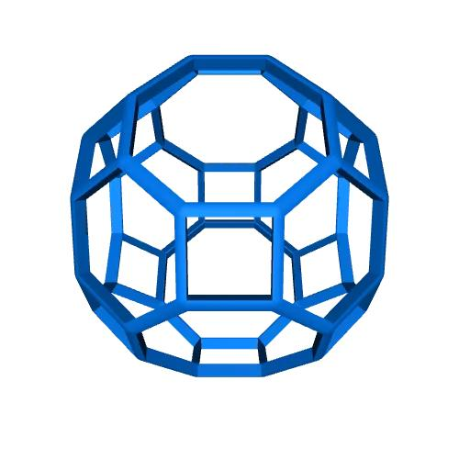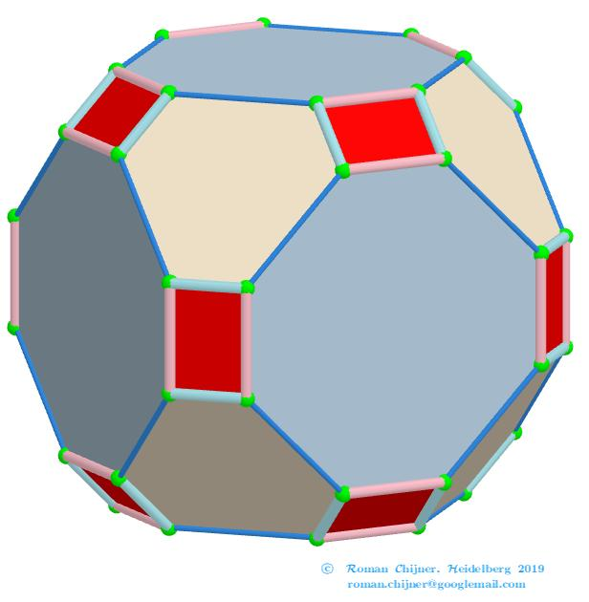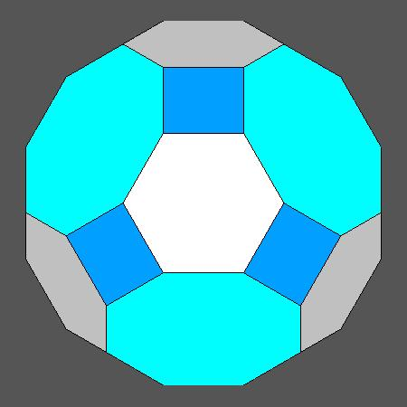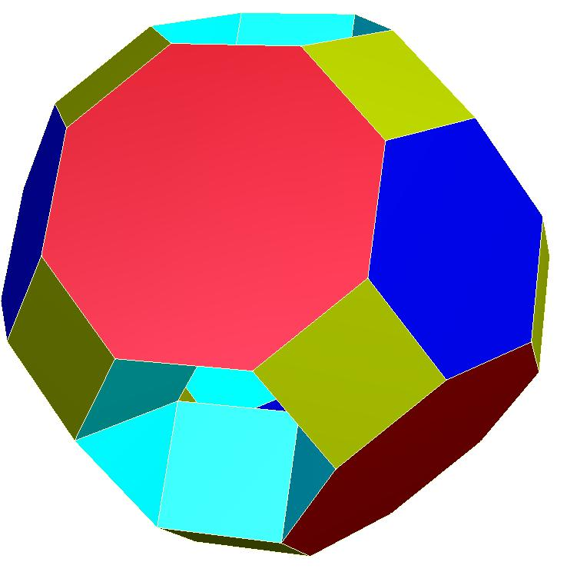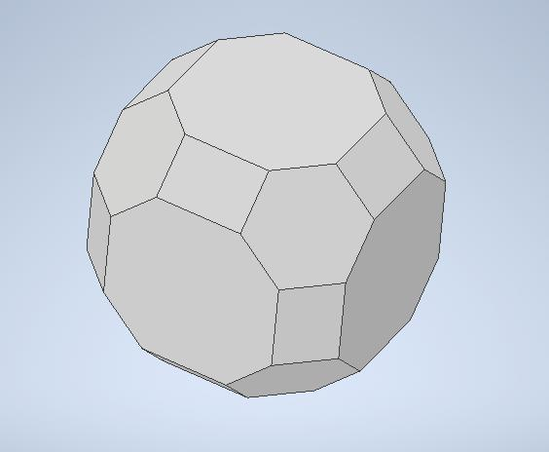
A truncated cuboctahedron consists of three types of polygonal faces:
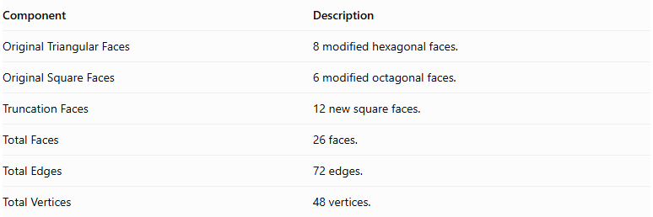
Component | Description
Original Triangular Faces | 8 modified hexagonal faces.
Original Square Faces | 6 modified octagonal faces.
Truncation Faces | 12 new square faces.
Total Faces | 26 faces.
Total Edges | 72 edges.
Total Vertices | 48 vertices.

Face Composition
# Source: AI Source: Provided by: [Data Path: Persons Table -> ID Column: 1, Name_En Column: Motasem Essam] -> From: [ChatGPT] on [7/25/2026]
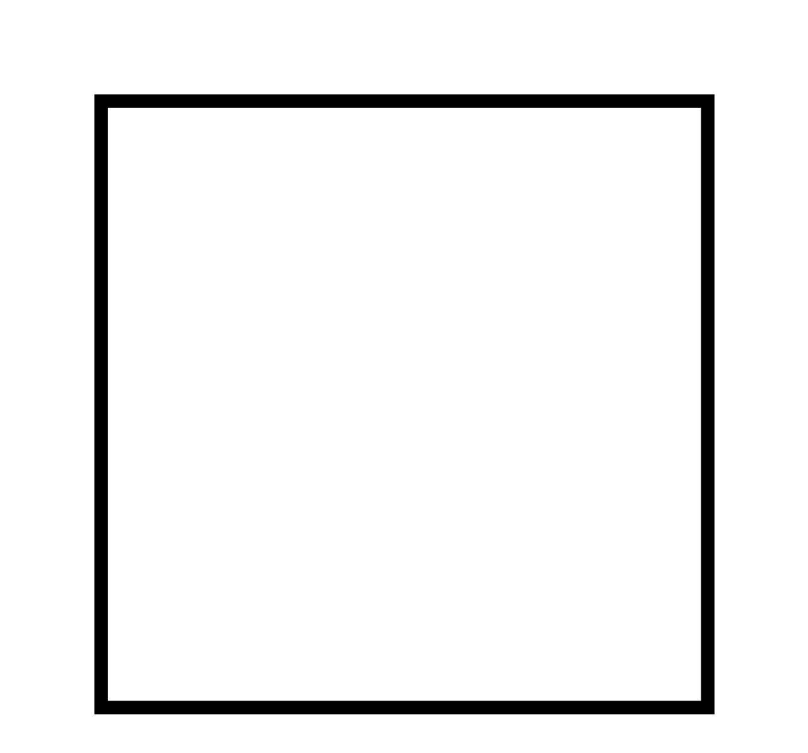

Square Faces
# Source: AI Source: Provided by: [Data Path: Persons Table -> ID Column: 1, Name_En Column: Motasem Essam] -> From: [ChatGPT] on [7/25/2026]
- Number: 12
- Shape: Regular squares.
- Origin: Created by truncating the twelve original vertices.
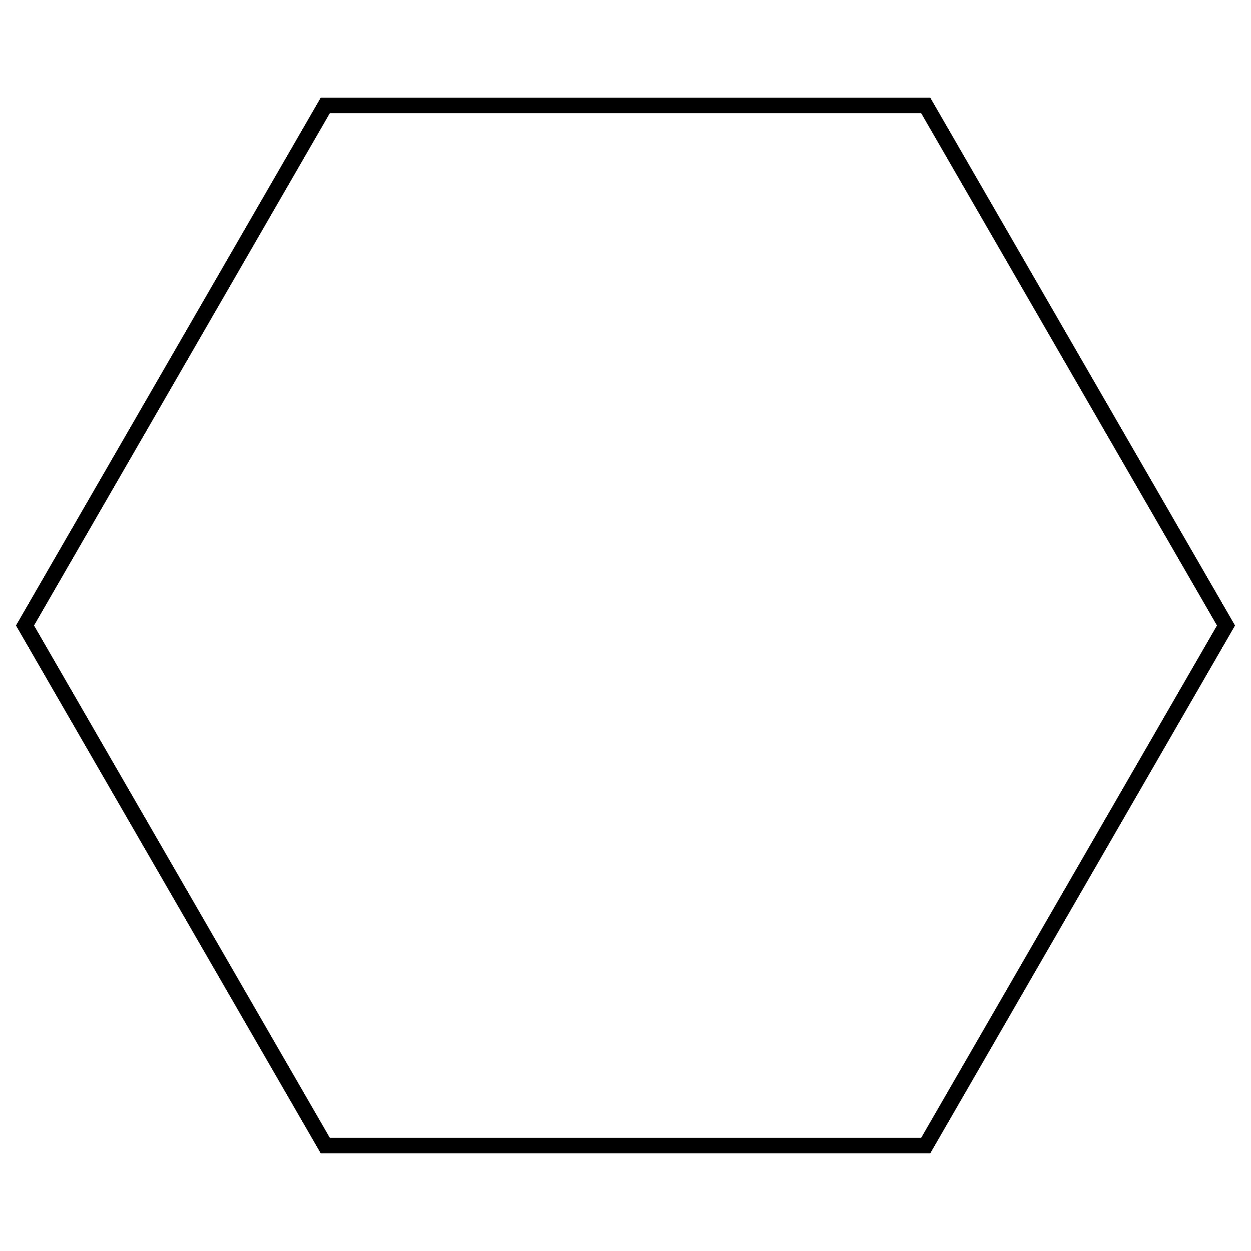

Hexagonal Faces
# Source: AI Source: Provided by: [Data Path: Persons Table -> ID Column: 1, Name_En Column: Motasem Essam] -> From: [ChatGPT] on [7/25/2026]
- Number: 8
- Shape: Regular hexagons.
- Origin: Modified from the eight original triangular faces.
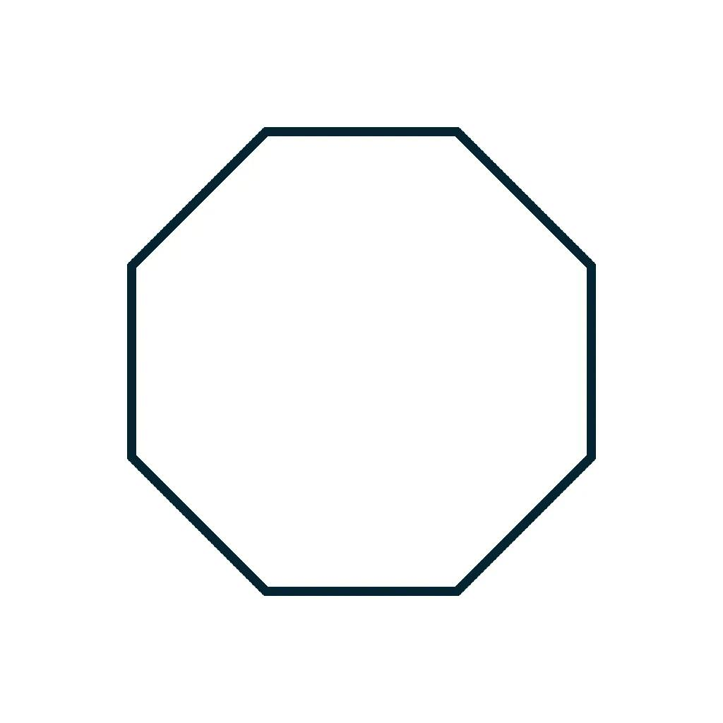

Octagonal Faces
# Source: AI Source: Provided by: [Data Path: Persons Table -> ID Column: 1, Name_En Column: Motasem Essam] -> From: [ChatGPT] on [7/25/2026]
- Number: 6
- Shape: Regular octagons.
- Origin: Modified from the six original square faces.

Mathematical Properties
# Source: AI Source: Provided by: [Data Path: Persons Table -> ID Column: 1, Name_En Column: Motasem Essam] -> From: [ChatGPT] on [7/25/2026]
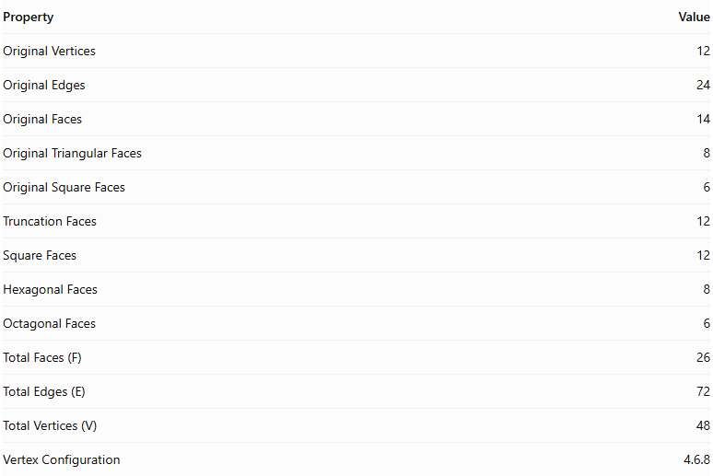
Property | Value
Original Vertices | 12
Original Edges | 24
Original Faces | 14
Original Triangular Faces | 8
Original Square Faces | 6
Truncation Faces | 12
Square Faces | 12
Hexagonal Faces | 8
Octagonal Faces | 6
Total Faces (F) | 26
Total Edges (E) | 72
Total Vertices (V) | 48
Vertex Configuration | 4.6.8
Euler's Formula:
$$V-E+F=2$$
Substituting:
$$48-72+26=2$$
Therefore, the truncated cuboctahedron satisfies Euler's formula.

Key Points
# Source: AI Source: Provided by: [Data Path: Persons Table -> ID Column: 1, Name_En Column: Motasem Essam] -> From: [ChatGPT] on [7/25/2026]
- It originates from a cuboctahedron.
- All twelve original vertices are truncated.
- It has 12 square faces, 8 regular hexagonal faces, and 6 regular octagonal faces.
- It contains 72 edges and 48 vertices.
- It is an Archimedean solid.
- Its faces are regular polygons.
- Three different types of polygons meet at every vertex.

Conclusion
# Source: AI Source: Provided by: [Data Path: Persons Table -> ID Column: 1, Name_En Column: Motasem Essam] -> From: [ChatGPT] on [7/25/2026]
The Truncated Cuboctahedron is an Archimedean solid formed by uniformly truncating the twelve vertices of a cuboctahedron. It consists of twelve square faces, eight regular hexagonal faces, and six regular octagonal faces, with a total of 26 faces, 72 edges, and 48 vertices.

